**Bug description**

Big 6: All six symbols were output expected of the testing, however, the actual results showed that "SPADE" value cannot be obtained.

**Bug resolution**

1. Add DiceValue.ROLL which will be exclusive for nextInt method.

Figure 1: Modified source code

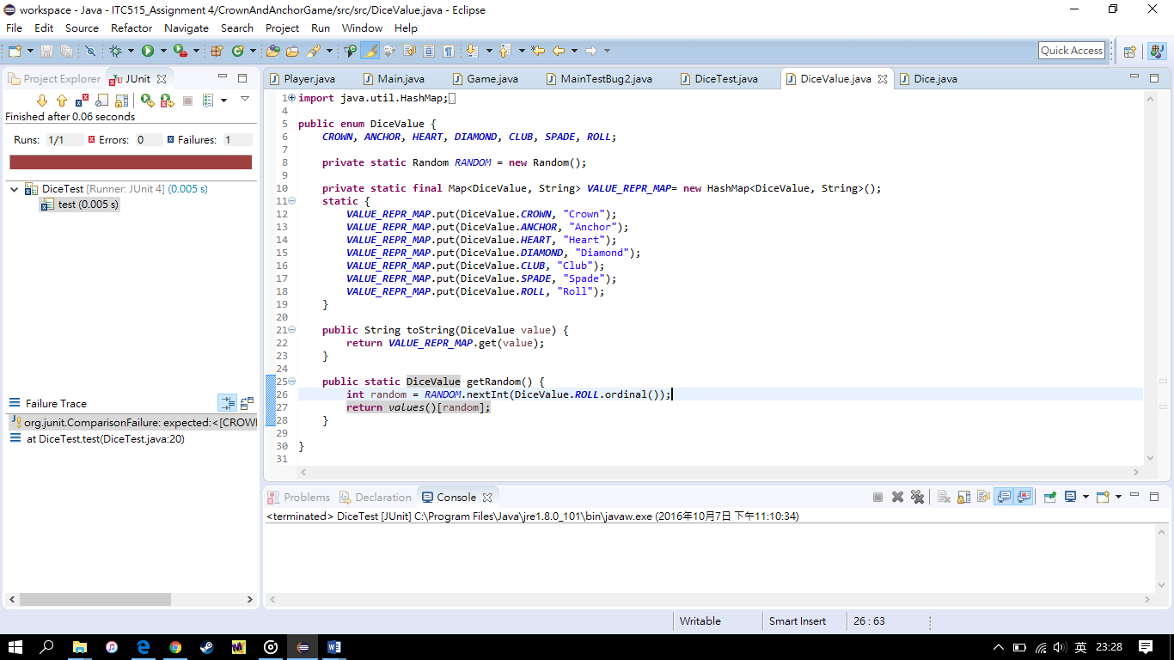

1. Test result.

Figure 2: Actual output of the program test (DiceTest.java)

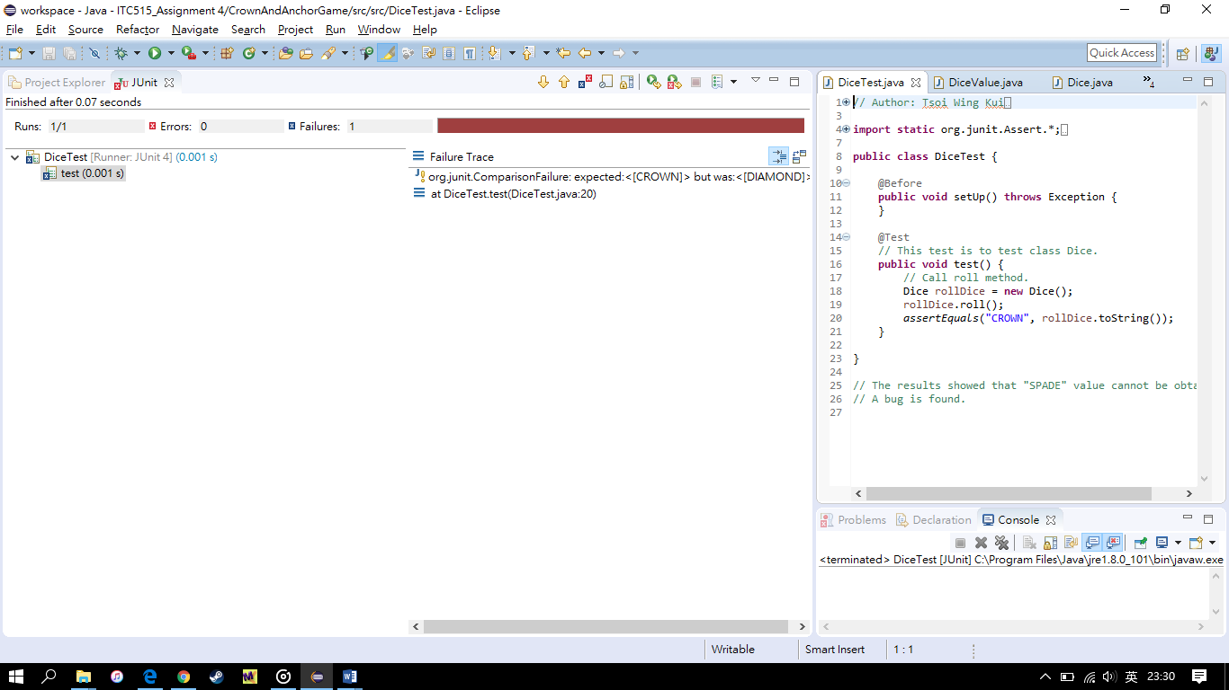

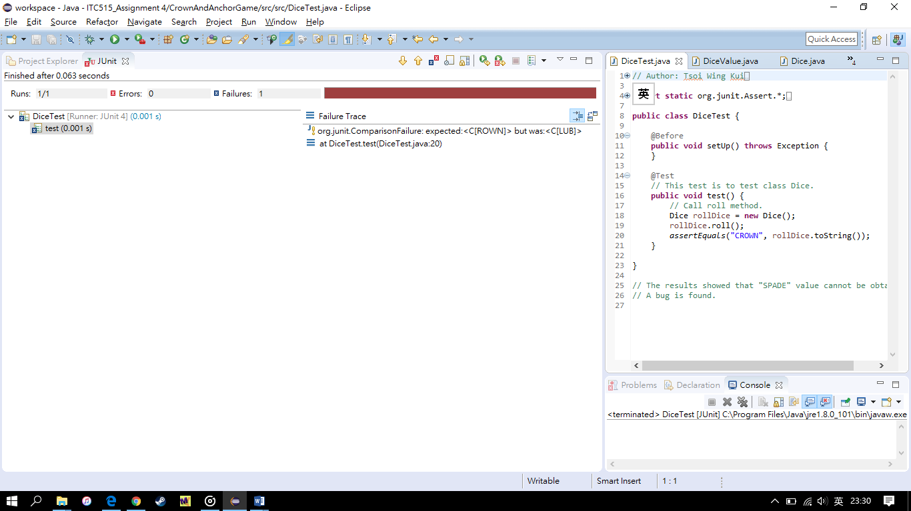

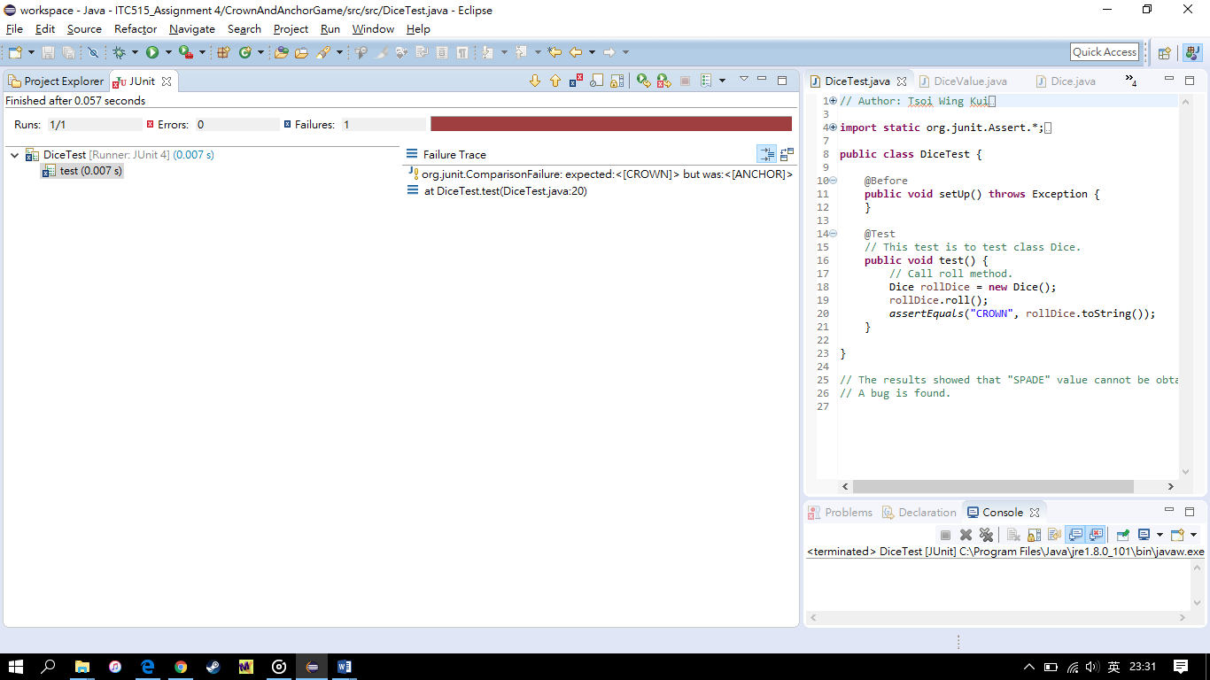

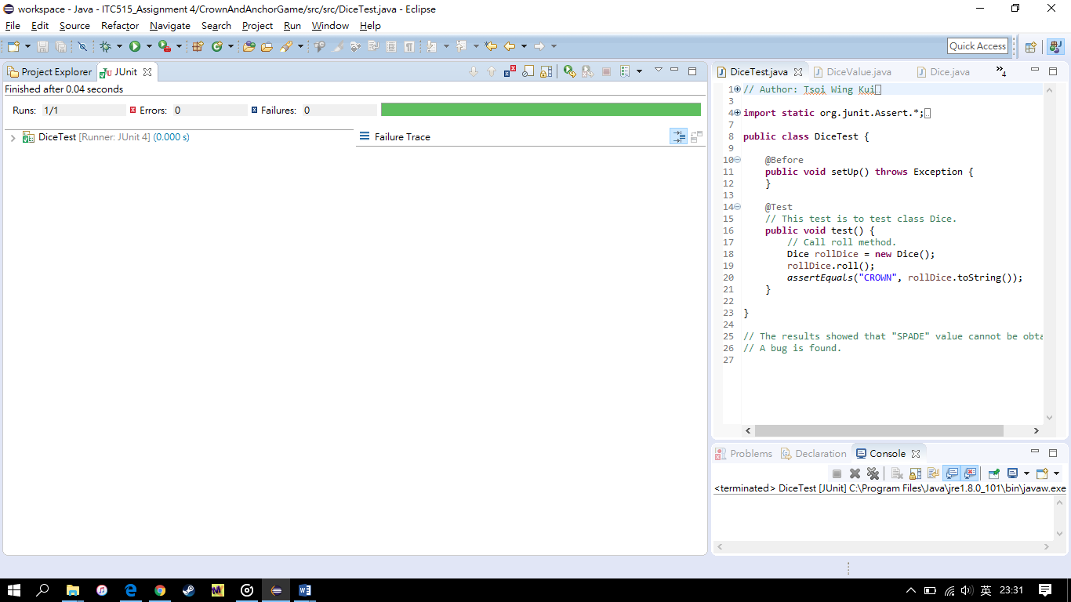

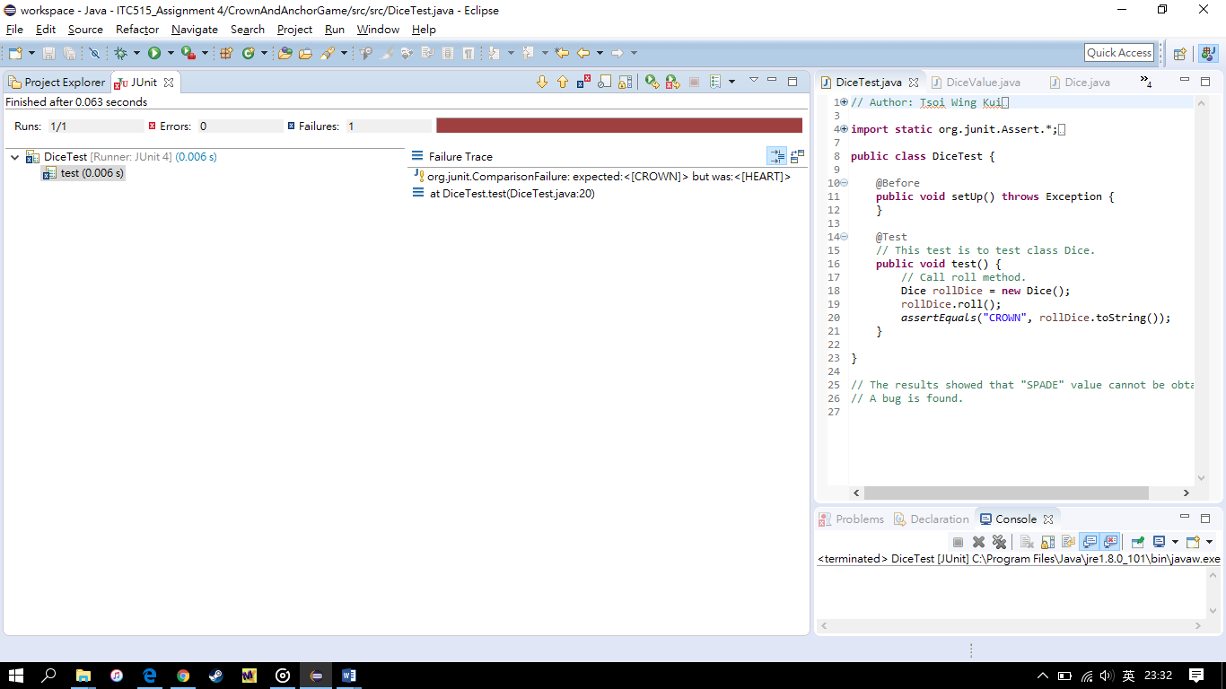

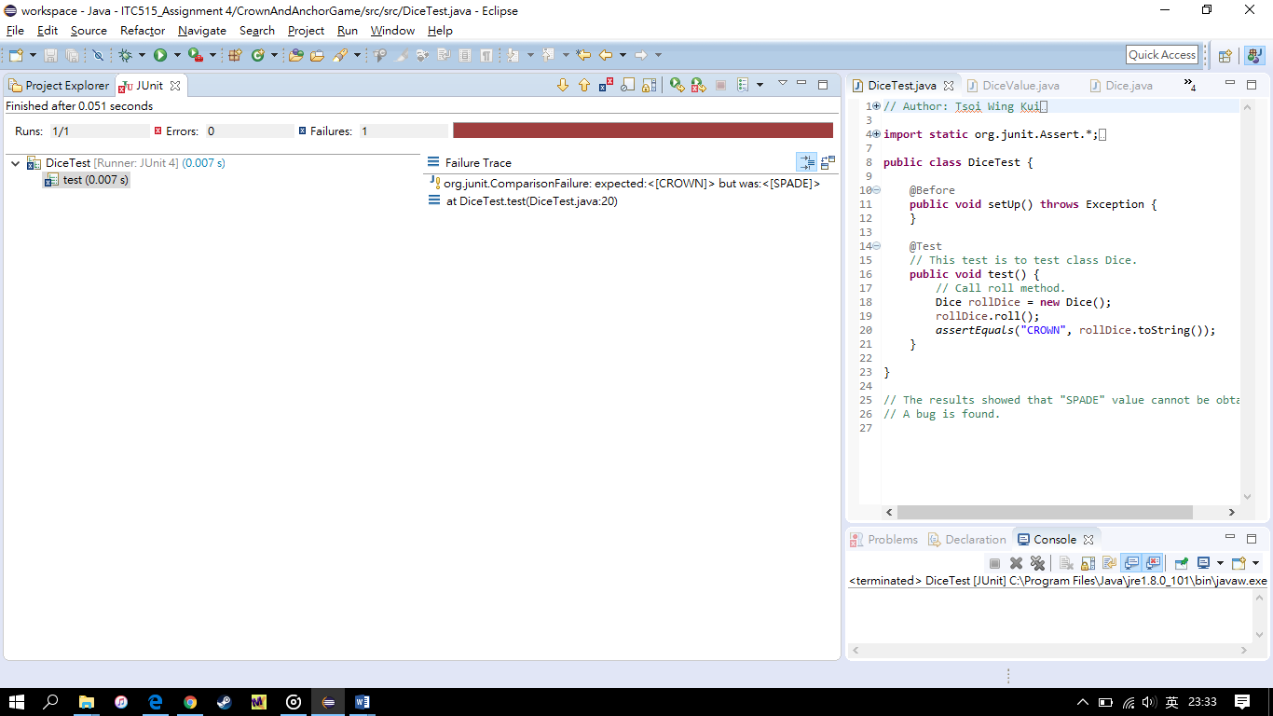

As Figure 2 shown, all symbols were shown so the bug is fixed.